How to Edit the Git

Author: Kemal Ahmed

Date: 2013-12-07

# Getting Access

1. Download the Github GUI
2. E-mail [me](mailto:goatandsheep@gmail.com?subject=Add%20me%20to%20the%20McMaster%20Notes%20Github%20pl0x) to ask me to give you collaborator status.
3. Open Github
4. Click on your username

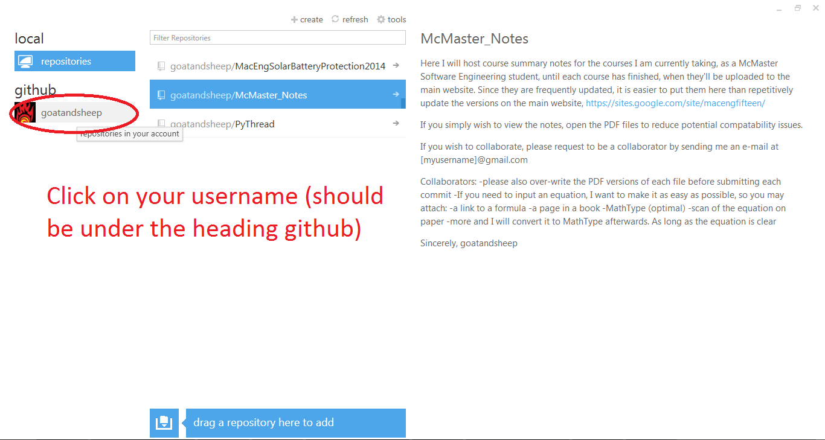

1. If you don’t see the repository McMaster_Notes, press the refresh button

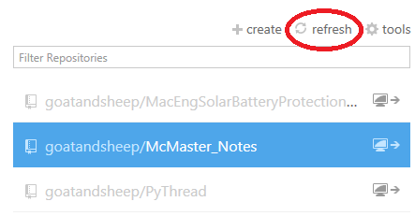

1. Once you see the repository, click the Mini Monitor icon to “Clone” it to your computer.

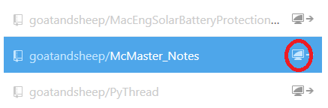

1. Go to %CurrentUser%/Documents/Github/McMaster_Notes and open the files you want, using Microsoft Word.

# Making Changes

1. Read the Readme on the side to make sure you’re making changes the way you should (which can be read when you click on the repository in the Github GUI).
2. Save the file in Microsoft Word.
3. Also save the file as a PDF in Microsoft Word
4. Open the Github GUI.
5. Select the McMaster_Notes repository and hit the right arrow.

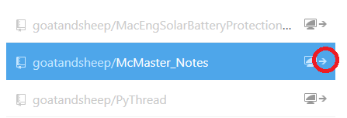

1. Fill in the part that says “Commit message”

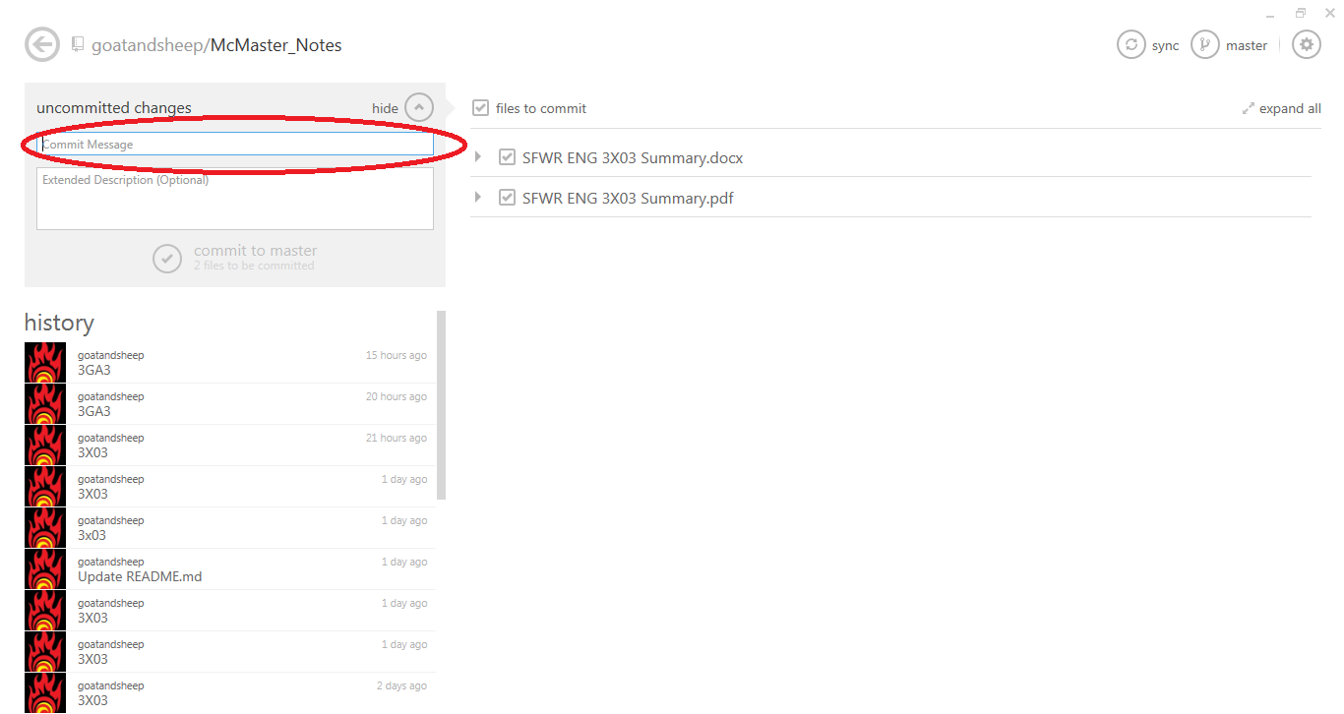

1. This will prompt the “Commit” or save changes button to become active. Hit that button.

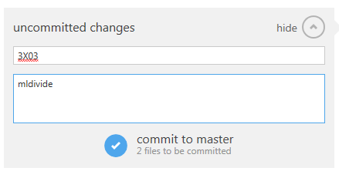

1. Press sync

